Scenario 5: How to create EC2 placement groups in AWS.
Cluster Placement groups.
Spread placement groups.
Partition placement groups.
EC2 placement groups is a logical grouping of instances that inf
Once you create a placement group (cluster, spread, or partition), AWS will automatically handle the placement of your instances according to the type you chose,
but here are some key points:
1. You need to ensure the right AZ
- Cluster Placement Group:
You must launch all instances in the same Availability Zone (AZ).
When launching EC2s, you need to select the same AZ manually.
- spread Placement Group:
AWS spreads the instances across different racks (hardware) and possibly AZs (only for EC2s in the same region, not Local Zones).
- Partition Placement Group:
You can specify how many partitions you want, and AWS will spread instances accordingly, but all must be in the same AZ unless using EC2 placement groups with multiple partitions supported.
2. When launching EC2s
- In the Advanced details, choose the placement group name.
- Choose the AZ if required (especially for Cluster and Partition types).
Step 1: select create a placement groups.
Ec2 console , under Network & Security > select Placement Groups.
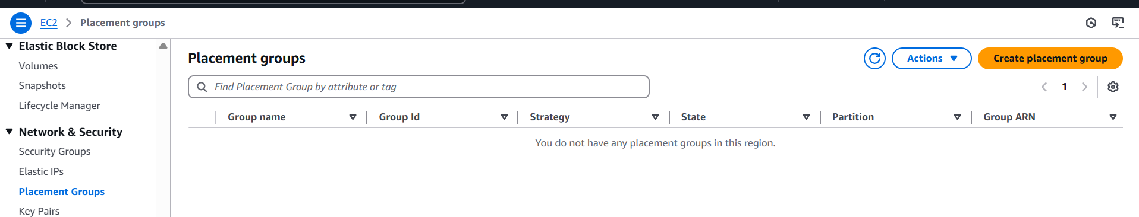Step 2: click on Create Placement Groups. For Cluster
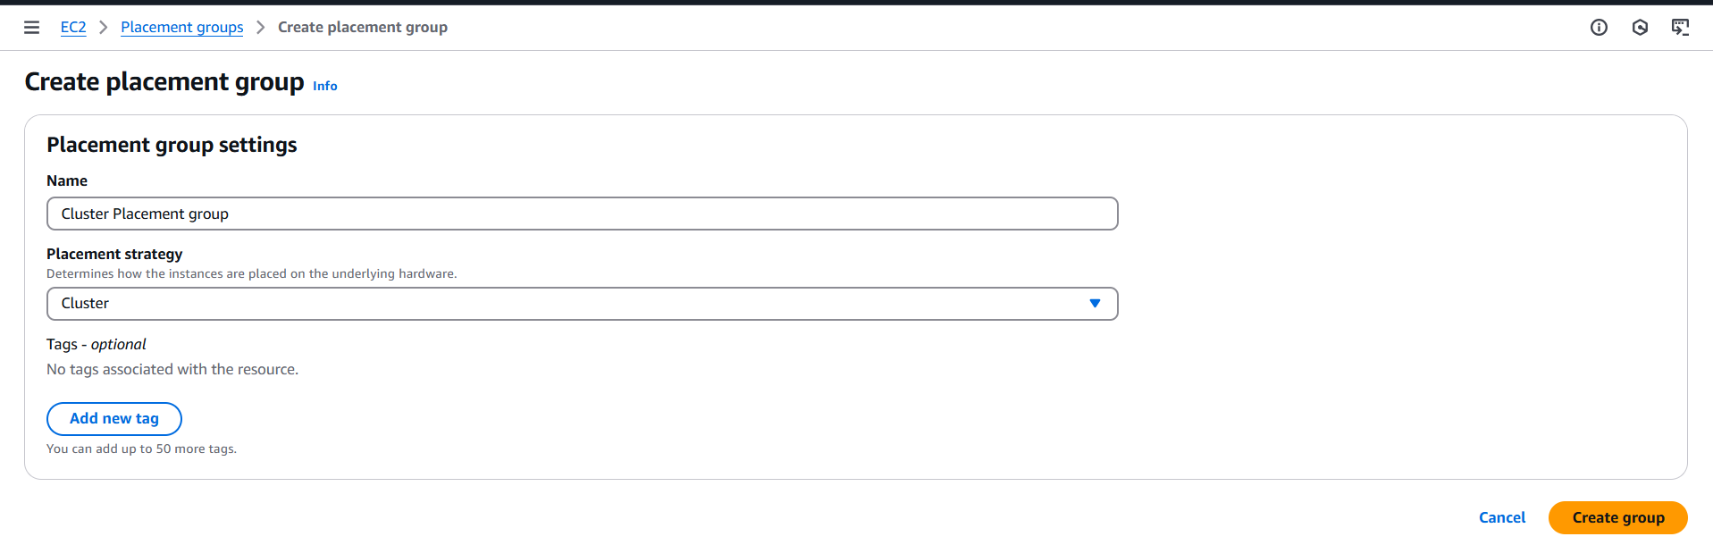
Step 3: click on Create Placement Groups. For Spread
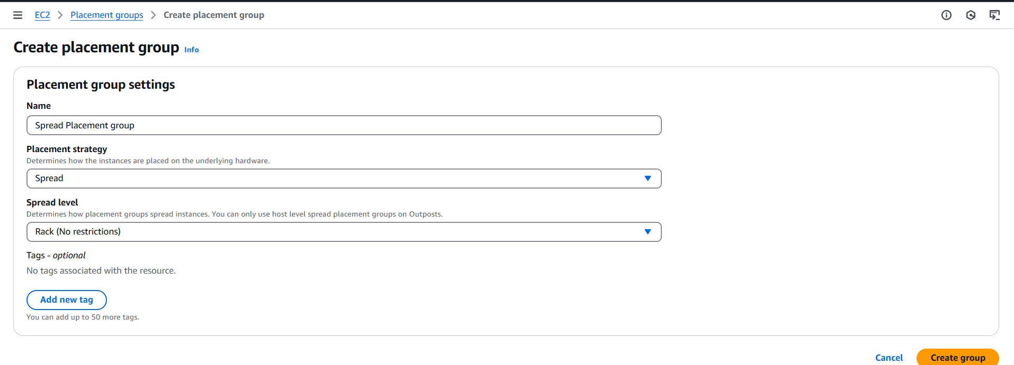
If you have outpost, then select outpost option.
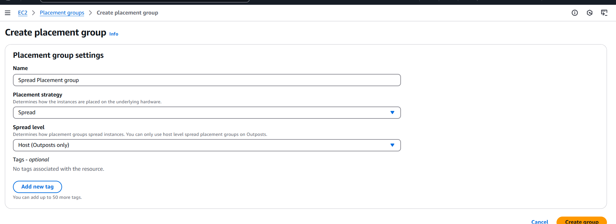

Step 4: click on Create Placement Groups. For Partition
Select the number of partition , it varies from 1-7 .

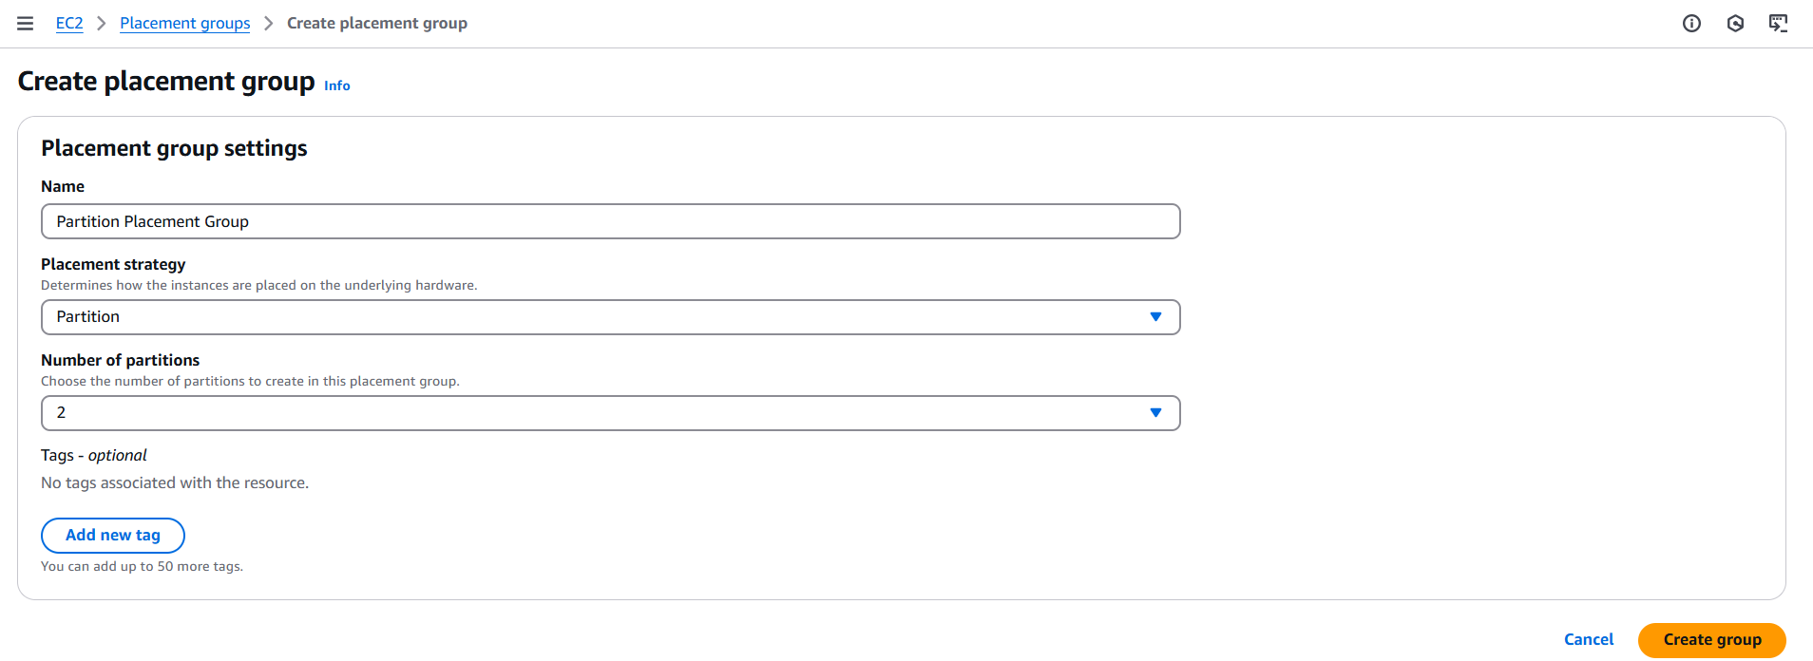
Validation
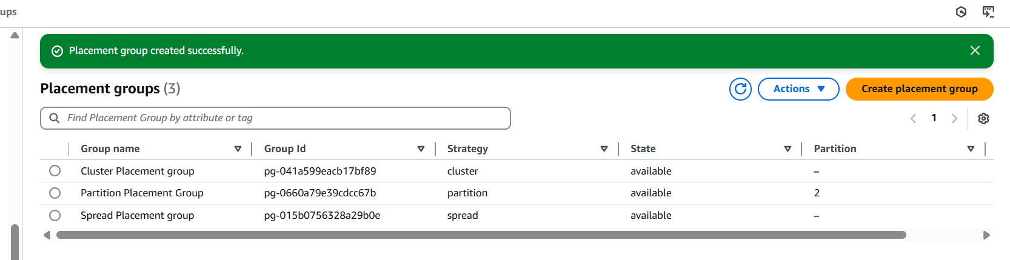
Step 5: Lets validate , lets launch and instance and check for each.
